Steps for Finding Fractions in Lowest Terms
Example
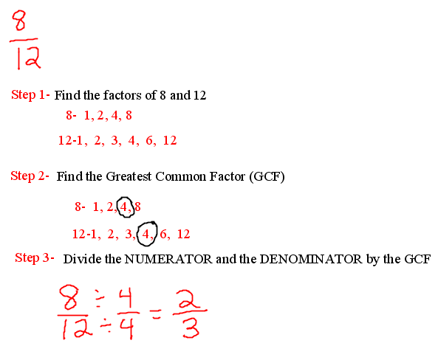
After these steps are understood and mastered, have your student use the tool to find the factors and the fraction in lowest terms.
Greatest Common Factor Tool- Greatest Common Factor Tool
When writing the answer, have your student do the following:
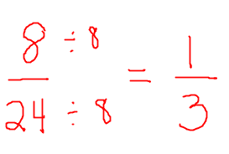
This will remind your student what to do once they find the GCF. Every now and then, have your student do one without the tool and then use the tool to check his answers.

